Wajenzi Professional co ltd Architect Bonus Scheme System V.1.0 Specification

1. Purpose
This document defines the Architect Bonus Scheme system used to calculate performance-based bonuses for architects based on project value, adherence to schedule, design quality, and client approval efficiency.

2. Bonus Unit Structure
S/N | Project Amount (TZS) | Units
1 | 1M and below | 1
2 | 1M – 3.5M | 2
3 | 3.5M – 7M | 4
4 | 7M – 12M | 5
5 | 12M – 15M | 7
6 | 15M – 20M | 10
7 | 20M – 30M | 15
8 | 30M – 40M | 20
9 | 40M – 50M | 25
10 | 50M – 60M | 30
11 | 60M – 70M | 35
12 | 70M – 80M | 40
13 | 80M – 90M | 45
14 | 90M – 100M | 50
1 Unit = 10,000 TZS

3. Task Information Stored in the System
• Task ID
• Project Name
• Architect Assigned
• Project Budget (Backend Only)
• Start Date
• Scheduled Completion Date
• Actual Completion Date
• Maximum Units
• Current Units
• Bonus Amount

4. Architect Visibility Rules
Architects can only view:
• Task Name
• Deadline
• Current Bonus Units
• Bonus Amount
• Task Status
Architects cannot view project budget or internal calculations.

5. Advanced Performance-Based Bonus Model
Schedule Performance (SP)
SP = Scheduled Duration / Actual Duration
Design Quality Score (DQ)
Rated by design manager using scale 0.4 – 1.0

Client Approval Efficiency (CA)
CA = 1 / Number of client revisions
Revisions | CA Score
1 revision | 1.0
2 revisions | 0.5
3 revisions | 0.33
4 revisions | 0.25

6. Performance Score Formula
PS = (0.4 × SP) + (0.4 × DQ) + (0.2 × CA)
SP cannot exceed 1.1 to avoid Uncontrolled bonus payouts-Architects could earn more than the intended budget.
Unrealistic rushing
Architects might rush work too quickly just to increase SP.
This can reduce:
- design coordination
- documentation quality
- safety checks
Meaning the maximum reward for early completion is 10% extra performance credit.

Example:
If Schedule Performance (SP) = 1.25
SP = min (1.25, 1.1)
SP = 1.1
SP = Scheduled Duration / Actual Duration
SP = min(SP, 1.1)

7. Final Units and Bonus Calculation
Final Units = Maximum Units × Performance Score
Final Units ≤ Max Units
Bonus Amount = Final Units × 10,000 TZS
If delay exceeds 50% of scheduled duration: No Bonus.
Example:
Scheduled = 10 days
If delay > 5 days, no bonus.

8. Example Calculation
Project Budget: 25M TZS
Maximum Units: 15
Scheduled Duration: 10 days
Actual Duration: 12 days
SP = 10 / 12 = 0.83
DQ = 0.9
CA = 0.5
PS = (0.4×0.83)+(0.4×0.9)+(0.2×0.5)=0.792
Final Units = 15 × 0.792 ≈ 12
Bonus = 12 × 10,000 = 120,000 TZS

9. System Process Flowchart
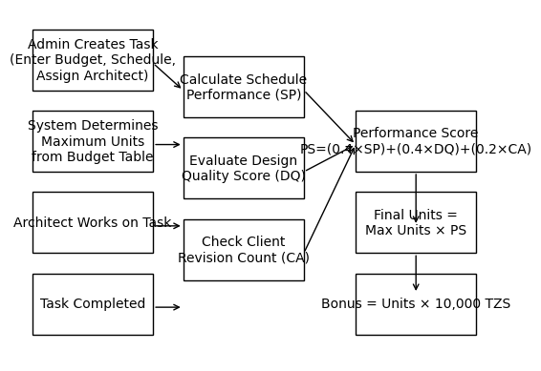

10. Reporting
The system should generate:
• Monthly architect bonus report
• Task completion performance report
• Total units earned per architect

11. Security Requirements
• Project budgets must remain hidden from architects.
• Only administrators can create tasks and edit budgets.
• Bonus calculations must run on the backend.

SYSTEM DEVELOPER NOTE*The weights are configurable. Wajenzi Professional company could choose:

ADDITIONAL NOTES – FOR MANAGEMENT

1. Why Schedule Performance (SP) = 40%
In architecture projects, time is critical because design delays affect:
- Construction start dates
- Contractor mobilization
- Financing schedules
- Client commitments
If the design team delays, the entire project chain can be delayed.
However, if schedule weight were too high (for example 70%), architects might rush designs and reduce quality.
So 40% keeps strong motivation to finish on time without encouraging rushed work.

2. Why Design Quality (DQ) = 40%
Design quality is equally important because poor designs create:
- Construction errors
- Cost overruns
- Rework
- Safety issues
- Client dissatisfaction
In many architecture firms, quality is considered just as important as speed, which is why it receives the same weight as schedule.
If quality weight were too low (for example 20%), architects might prioritize speed over correctness, which can damage the firm’s reputation.
Therefore:
40% schedule + 40% quality = balanced professional performance

3. Why Client Approval Efficiency (CA) = 20%
Client approval matters, but it is partially outside the architect’s control. Clients may request changes for reasons unrelated to the design quality, such as:
- Budget changes
- Personal preferences
- Regulatory adjustments
- Market conditions
If this factor had too much weight, architects might be unfairly penalized for things they cannot control.
So firms usually give it a smaller weight, like 20%, which still encourages:
- Clear presentations
- Understanding client requirements
- Minimizing revisions
but prevents it from dominating the bonus calculation.

4. The Balance Logic
The formula balances the three main goals of design firms:
Objective | Weight | Reason
Finish work on time | 40% | Keeps projects on schedule
Maintain design quality | 40% | Protects firm reputation
Reduce revisions | 20% | Improves client satisfaction
This structure encourages professional behavior instead of speed-only performance.

5. Example of What Happens if We Change the Weights
Case A: 70% Schedule, 20% Quality, 10% Client
Result:
- Architects rush designs
- Quality drops
- More construction errors

Case B: 30% Schedule, 60% Quality, 10% Client
Result:
- Designers over-perfect drawings
- Projects become slow
- Deadlines missed

Case C: 40% – 40% – 20% (Balanced)
Result:
- Good speed
- Good design quality
- Fewer revisions
This is why many consulting firms use balanced weighting systems.

6. Important: These Percentages Can Be Adjusted
The weights are configurable. Your company could choose:
Example alternatives:
Model | SP | DQ | CA
Speed-focused firm | 50% | 30% | 20%
Quality-focused firm | 30% | 50% | 20%
Client-focused firm | 35% | 35% | 30%
But 40/40/20 is commonly used because it balances all objectives.

✅ Recommendation for your system:
Keep these weights configurable in the database, so management can adjust them later without changing the software.
Example database table:
factor | weight
schedule | 0.4
quality | 0.4
client | 0.2

